# Question 1

A particular computer uses a **normalised** floating point representation with a 7-bit

mantissa and a 5-bit exponent, both stored using **two’s complement**.

Four bit patterns that are stored in this computer’s memory are listed in **Figure 3** and labelled with the letters **A** to **D**. Three of the bit patterns are valid floating point numbers and one is not.

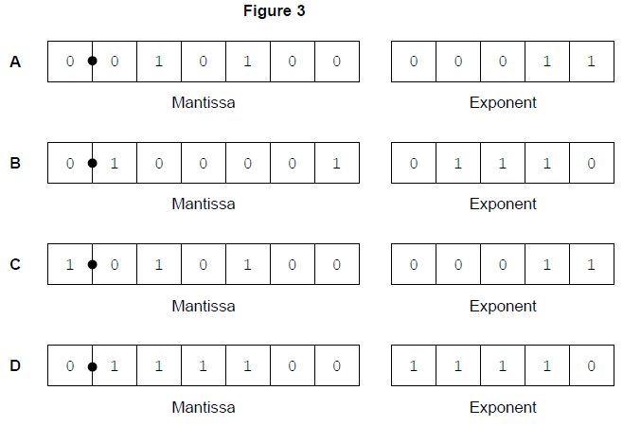

1. Complete **Table 2** below. In the **Correct letter (A-D)** column write the appropriate letter from **A** to **D** to indicate which bit pattern in **Figure 3** matches the description in the **Value description** column. Do **not** use the same letter more than once. **[3 marks]**

|  |  |
| --- | --- |
| **Value description** | **Correct letter (A-D)** |
| A negative value | C |
| The largest positive number of the four values | D |
| A value that is not valid in the representation because it is not normalised | B |

This is a floating point representation of a number:

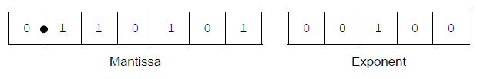

1. Calculate the denary equivalent of the number. Show how you have arrived at your answer.

Working

(32+16+0+4+0+1) / (0+0+4+0+0) = 53 / 4 = 13.25 …………………………………………….. **[1 mark]**

Answer

13.25 ...................................................................................................................................... **[1 mark]**

This is a floating point representation of a number:

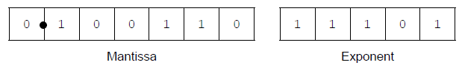

1. Calculate the denary equivalent of the number. Show how you have arrived at your answer.

Working

(32+0+0+4+2+0) / (16+8+4+0+1) = 40 / 29 = 1.379310344827586 .......................... **[1 mark]**

Answer

1.379310344827586 ................................................ **[1 mark]**

1. Write the normalised floating point representation of the denary value 2944 in the boxes below. Show how you have arrived at your answer. **[2 marks]**

Working

2944 / 16(16ex) = 184 (mant)........................................................................................ **[1 mark]**

Answer (Should be in the Mantissa and Exponent form shown below)

1 ~ 1 1 1 1 1 1 0 1 1 1 0 ……............................................................. **[1 mark]**

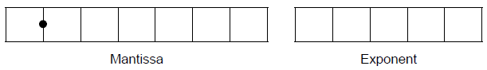

1. There can be a loss of precision when a denary number is stored using this floating point system.

The closest possible representation of the denary number 12.87 is shown below:

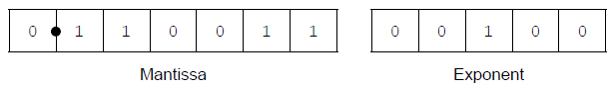

By converting this bit pattern back into denary, it can be seen that the actual number

stored is 12.75, not 12.87.

1. Calculate the absolute error that has occurred. **[1 mark]**

0.12 .........................................................................................................................

1. Calculate the relative error that has occurred. Express your answer as a percentage to four decimal places. **[1 mark]**

0.0012 ...........................................................................................................................

1. Sometimes a floating point calculation can produce a result that is so close to zero that the result’s closest possible representation is zero. What is the name given to this specific type of error? **[1 mark]**

Rounding Error ....................................................................................................................

# Question 2

A computer program is being developed for a car hire company. The program must store, in a file, details of the 600 vehicles that the company owns.

The records in the file will be stored and retrieved using hashing.

An alternative method that could be used instead of hashing would be to store the records in order of registration number, and use a search algorithm such as binary search for retrieval.

1. State **one** advantage of organising the data using hashing instead of organising the data in order by registration number. **[1 mark]**

The data will be more secure …..........................................................................

1. State **one** advantage of organising the data in order by registration number instead of organising the data using hashing. **[1 mark]**

The data will be faster to compute ...................................................................

Each vehicle is uniquely identified by its registration number. A registration number

consists of:

* two alphabetic characters
* followed by two numeric digits
* followed by three further alphabetic characters.

An example registration number is DA18CFE.

The programmer has chosen the hash function on the next page to calculate a hash

value from a registration number.

Hash value = ( position in alphabet of letter at position 1 +

position in alphabet of letter at position 2 * 10 +

numeric digit at position 3 * 100 +

numeric digit at position 4 * 500 ) MOD 1000

For the example DA18CFE the hash value would be calculated as follows:

Hash value = ( position in alphabet of ‘D’ (4) +

position in alphabet of ‘A’ (1) * 10 +

1 * 100 +

8 * 500 ) MOD 1000

= 4114 MOD 1000

= 114

1. Calculate the hash values for the following **two** registration numbers. You may use the space provided for working, if required. **[1 mark]**

**AE21KWB**

Working

Pos in AB of A = 1 + Pos in AB of E = 5 * 10 + 2 * 100 = 200 + 1 * 500 = 500 MOD 1000. (1 + 50 + 200 + 500) MOD 1000 =

751 MOD 1000 = 751 ............................................................................................................................................

Hash value

751

**KD70DAF**

Working

11 + (4 * 10) + (7 * 100) + (0 * 500) MOD 1000 =

11 + 40 + 700 + 0 MOD 1000 =

751 MOD 1000 = 751

............................................................................................................................................

Hash value

751

............................................................................................................................................

1. Calculating the hash values for the two registration numbers in part **5(b)** has produced a collision.

In the context of storing data in files using hashing, explain the effect of this collision and how this might be dealt with. **[2 marks]**

Two separate registrations can create the same value, resulting in multiple points of data for the same hash, meaning that the system have errors and maybe even crash. ............................................................................................................................................

............................................................................................................................................

# Question 3

**Figure 4** shows four graphs, labelled with the letters **A** to **D**.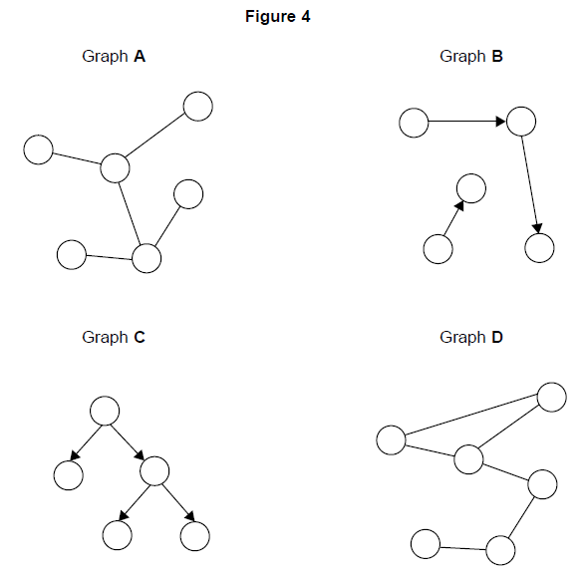

1. Complete **table** below. In the **Correct letter (A-D)** column write the appropriate letter from **A** to **D** to indicate which graph in **Figure 4** matches the description in the **Description** column. Do **not** use the same letter more than once. You will not need to use all of the letters. **[2 marks]**

|  |  |
| --- | --- |
| Description | Correct letter (A-D) |
| A graph that is not connected | B |
| A graph that is a tree | C |

It is possible to represent a computer network as a graph, with each vertex representing a router and each edge representing a communications link.

**Figure 5** is a graph representation of a medium-sized computer network that consists of 6 routers and 7 communications links. The routers have been numbered from 1 to 6.

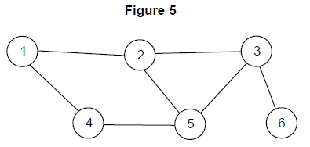

1. Complete **Table 4** below to show how the graph in **Figure 5** would be stored using an adjacency matrix. **[2 marks]**

I don’t know what an adjacency matrix is, sorry.

|  |  |  |  |  |  |  |
| --- | --- | --- | --- | --- | --- | --- |
|  |  |  |  |  |  |  |
|  |  |  |  |  |  |  |
|  |  |  |  |  |  |  |
|  |  |  |  |  |  |  |
|  |  |  |  |  |  |  |
|  |  |  |  |  |  |  |
|  |  |  |  |  |  |  |

# Question 4

1. Complete the truth table below for a NAND gate. **[1 mark]**

|  |  |  |
| --- | --- | --- |
| Input A | Input B | Output |
| 0 | 0 | 0 |
| 0 | 1 | 1 |
| 1 | 0 | 1 |
| 1 | 1 | 0 |

1. Multiplexors are used in electronic switching. A 2-to-1 multiplexor has a Boolean equation where A and B are two inputs, S is the selector input, and Q is the output.



1. Complete the truth table for the above Boolean equation. **[3 marks]**

|  |  |  |  |  |  |  |
| --- | --- | --- | --- | --- | --- | --- |
| **S** | **A** | **B** |  |  | **B.S** | **Q** |
| 0 | 0 | 0 | 1 | 0 | 1 | 1 |
| 0 | 0 | 1 | 1 | 0 | 0 | 0 |
| 0 | 1 | 0 | 1 | 1 | 1 | 1 |
| 0 | 1 | 1 | 1 | 1 | 0 | 1 |
| 1 | 0 | 0 | 0 | 1 | 0 | 1 |
| 1 | 0 | 1 | 0 | 1 | 1 | 1 |
| 1 | 1 | 0 | 0 | 0 | 0 | 0 |
| 1 | 1 | 1 | 0 | 0 | 1 | 1 |

1. Draw a circuit for the Boolean equation in the rectangle below. **[4 marks]**

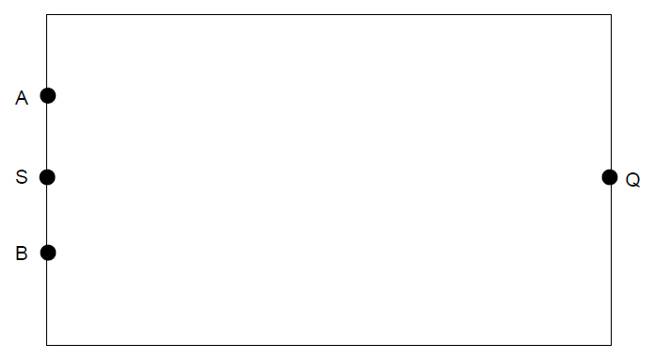

# Question 5

1. Represent the **denary** number 55 using **8-bit unsigned binary**. **[1 mark]**

11000111............................................................................................................................................

1. Represent the **denary** number 55 using **hexadecimal**. **[1 mark]**

53 53 00............................................................................................................................................

1. Why are bit patterns often displayed using hexadecimal instead of binary? **[1 mark]**

Because hex has more values available. ........................................................................................

1. Represent the denary number -59 as an **8-bit two’s complement binary integer**. **[2 marks]**

1100 1011...................................................................................................................................

1. Represent the denary number 5.625 as an **unsigned binary fixed point number** with three bits before and five bits after the binary point. **[2 marks]**

............................................................................................................................................

The ASCII system uses 7 bits to represent a character. The ASCII code in denary for

the numeric character ‘0’ is 48; other numeric characters follow on from this in sequence.

The numeric character ‘0’ is represented using 7 bits as 0110000.

1. Using 7 bits, express the ASCII code for the character '6' in binary. **[1 mark]**

54 1110110............................................................................................................................................

1. How many different character codes can be represented using 7-bit ASCII? **[1 mark]**

128............................................................................................................................................

Examples of logical bitwise operators include AND, OR, NOT and XOR.

1. Describe how **one** of these logical bitwise operators can be used to convert the 7-bit ASCII code for a numeric character into a 7-bit pure binary representation of the number, (eg 0110001 for the numeric character '1' would be converted to 0000001). **[2 marks]**

............................................................................................................................................

Characters are transmitted using an 8-bit code that includes the 7-bit ASCII code and a

single parity bit in the most significant bit. A parity bit is added for error checking during

data transmission.

1. Using even parity, what 8-bit code is sent for the numeric character '0'? **[1 mark]**

............................................................................................................................................

Hamming code is an alternative to the use of a single parity bit. Hamming code

uses multiple parity bits - this allows it to correct some errors that can occur during

transmission.

The parity bits are located in the power of two bit positions (1, 2, 4, 8, etc.). The other

bit positions are used for the data bits.

1. Describe how the receiver can detect and correct a single-bit error using Hamming code. **[4 marks]**

............................................................................................................................................

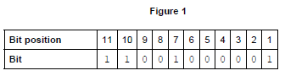

**Figure 1** shows the bit pattern **received** in a communication that is using **even parity**

Hamming code. The data bits received are 1101000.

There has been a single-bit error in the data transmission.

1. Which bit position from the bit pattern in **Figure 1** contains an error? **[1 mark]**

............................................................................................................................................